SETUP 1

Dual-Heater PCB Beam
MISO System Identification
Revised experiment: Heater 1 → Heater 2 → both heaters
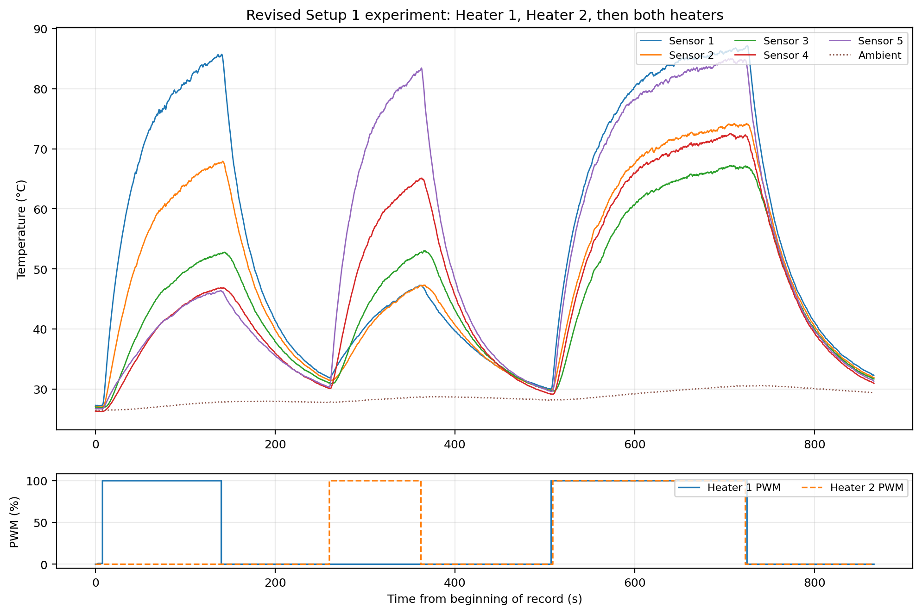
Figure 1. Complete revised experiment, including all three excitation blocks.
Source data | Setup1.txt
System structure | Two heater inputs and five temperature outputs
Model family | First-order plus dead time (FOPDT)
Primary conclusion | Independent paths are nearly symmetric; dual operation requires power/gain correction

1. Executive summary
- The revised recording independently excites Heater 1, Heater 2, and then both heaters, so all ten heater-to-sensor paths can be identified without assuming perfect geometric symmetry.
- The two independently identified heater paths are close to mirror images. Heater 2 produces approximately 2–7% more temperature rise than the corresponding mirrored Heater 1 path.
- Direct linear superposition overpredicts the dual-heater response. The best common dual-operation factor is approximately α = 0.717, with output-specific values from 0.692 to 0.769.
- If the full reduction were caused only by voltage sag, the effective heater voltage would need to fall from 5.00 V to approximately 4.23 V. A genuinely small sag therefore explains only part of the difference.
- The recommended model uses independently identified MISO paths, voltage-squared input normalization, and an additional temperature-dependent or dual-operation correction factor.
Key engineering conclusion
The revised experiment validates the symmetric two-input structure, but it does not support one globally linear model across single-heater and dual-heater operating regions. Voltage sag is physically plausible and should be measured directly, while the remaining reduction should be treated as temperature-dependent thermal loss.

2. Experiment sequence and data preparation
The log contains synchronized ambient temperature, five beam temperatures, and two independent heater commands. The three excitation blocks are separated by cooling periods, allowing the two heater paths to be estimated independently before validating their combined response.
Experiment | Input state | Start (s) | Stop (s) | Duration (s)
1 | Heater 1 only | 14.889 | 147.097 | 132.208
2 | Heater 2 only | 267.380 | 369.340 | 101.960
3a | Both: H1 command | 514.198 | 732.125 | 217.927
3b | Both: H2 command | 516.002 | 730.316 | 214.314
Table 1. Heater command sequence in the revised experiment.
The modeled output is the temperature rise relative to ambient:
$$Θ_{i}(t) = T_{i}(t) - T_{ambient}(t)$$

3. MISO model structure
Each sensor is treated as one single-output subsystem driven by the two heater inputs. Together, the five subsystems form a two-input/five-output plant.
$$Θ_{i}(s) = G_{i1}(s)U_{1}(s) + G_{i2}(s)U_{2}(s), i = 1,…,5$$
Each input-to-output path is represented by a first-order-plus-dead-time transfer function:
$$G_{ij}(s) = \frac{K_{ij}e^{-Lᵢⱼs}}{τ_{ij}s + 1}$$
The gain K is the nominal steady-state ambient-corrected temperature rise for a unit heater command, L is the apparent transport delay, and τ is the dominant thermal time constant.

4. Independently identified heater paths
Sensor | H1 gain K₁ | H1 delay L₁ | H1 τ₁ | H2 gain K₂ | H2 delay L₂ | H2 τ₂
S1 | 54.82 °C | 1.02 s | 35.69 s | 21.70 °C | 1.48 s | 64.76 s
S2 | 40.49 °C | 4.04 s | 43.49 s | 22.83 °C | 7.85 s | 60.62 s
S3 | 27.12 °C | 9.23 s | 52.84 s | 28.95 °C | 8.21 s | 52.85 s
S4 | 21.90 °C | 8.93 s | 57.59 s | 41.12 °C | 3.46 s | 43.65 s
S5 | 20.57 °C | 1.59 s | 60.08 s | 56.21 °C | 0.00 s | 34.54 s
Table 2. Identified FOPDT parameters for all ten heater-to-sensor paths.
Identification quality
The isolated-pulse fits produced R² values of approximately 0.9985–0.9992, with RMSE values of approximately 0.26–0.70 °C. These results support the FOPDT representation as a control-oriented model of each path.

4.1 Heater 1 identification
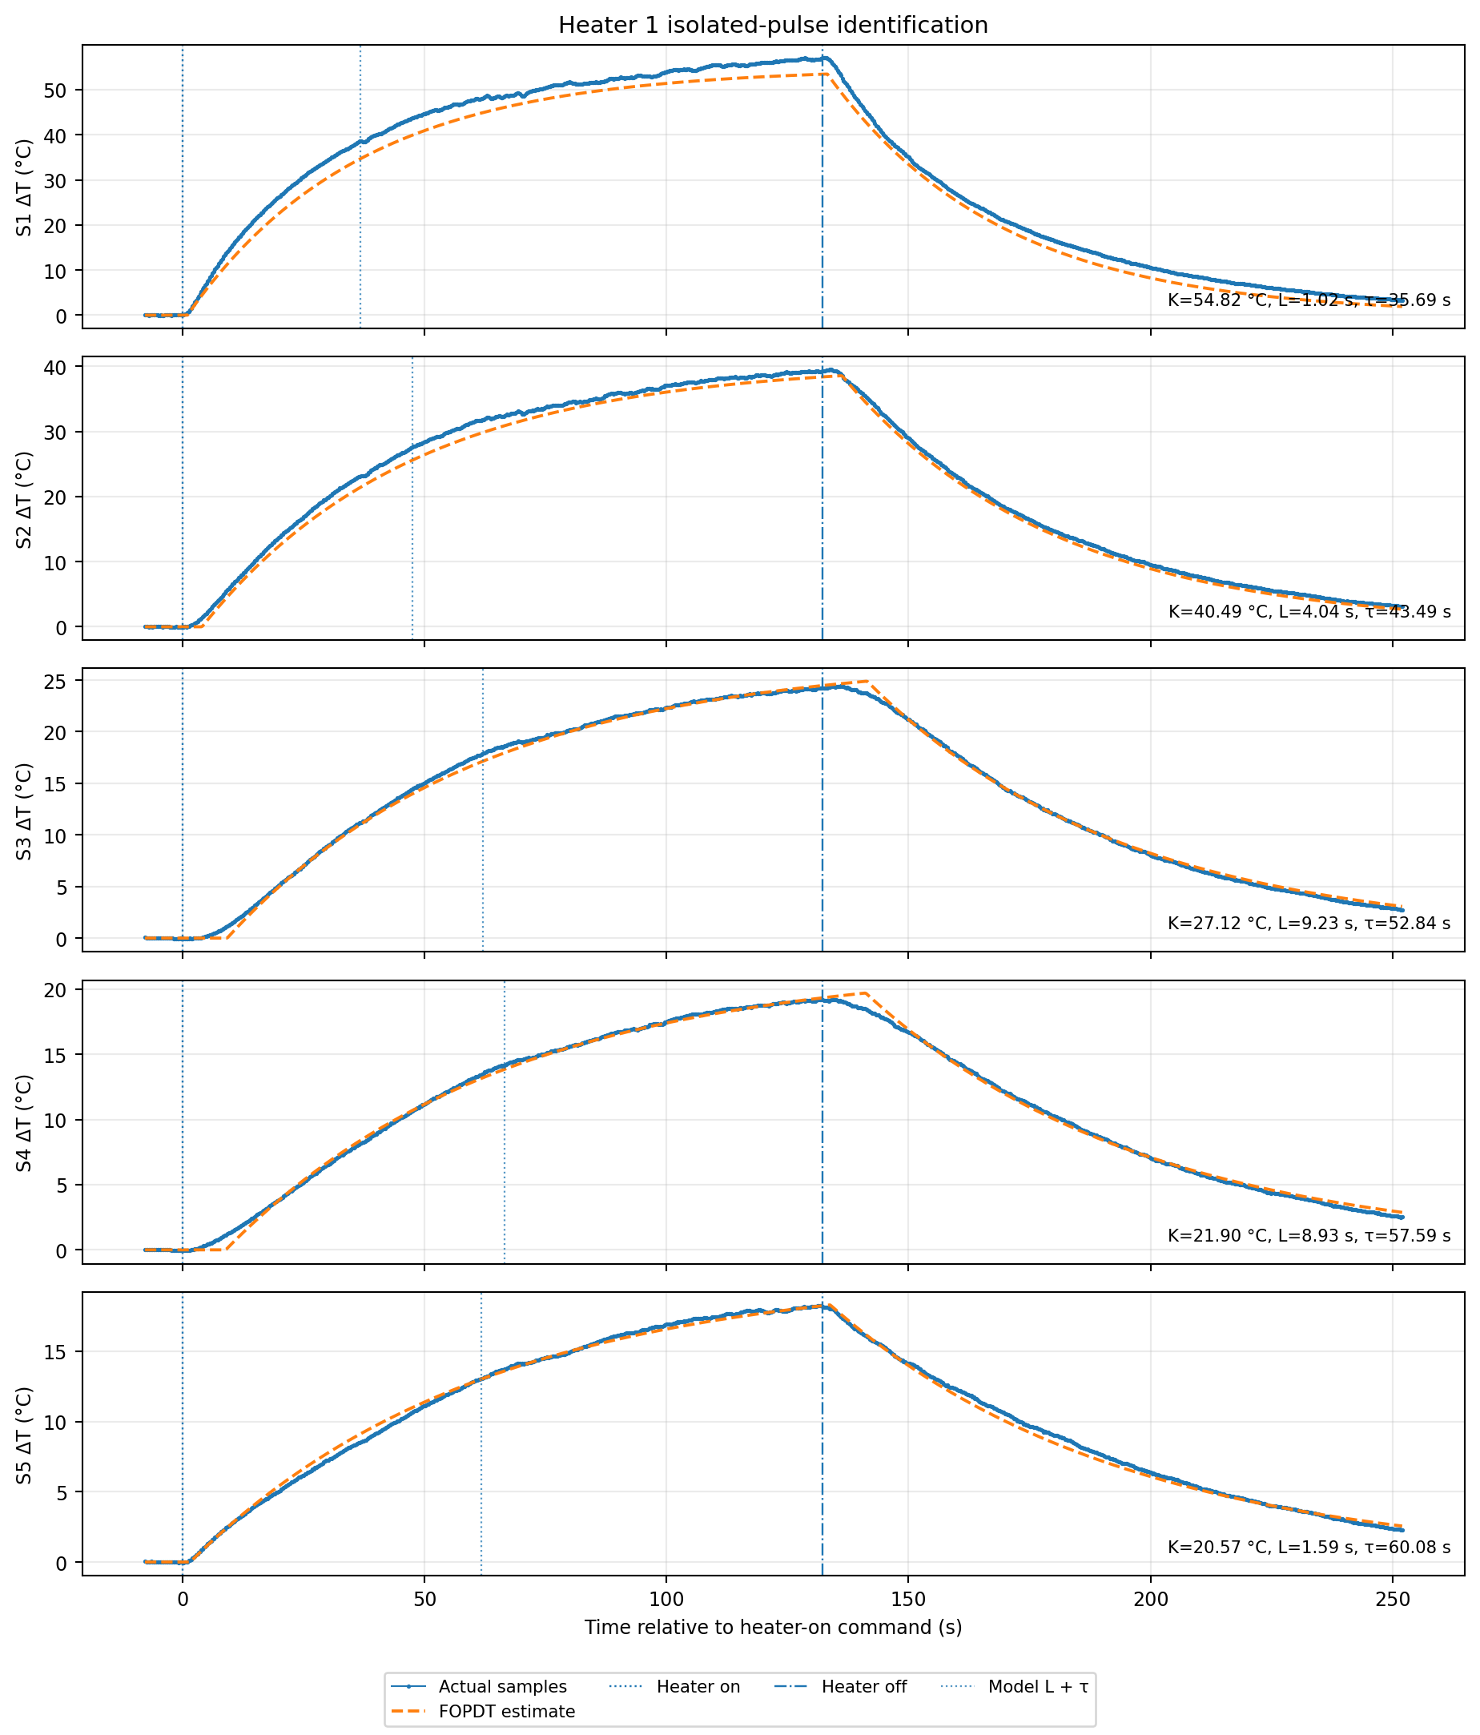
Figure 2. Ambient-corrected samples and FOPDT estimates for the isolated Heater 1 pulse.

4.2 Heater 2 identification
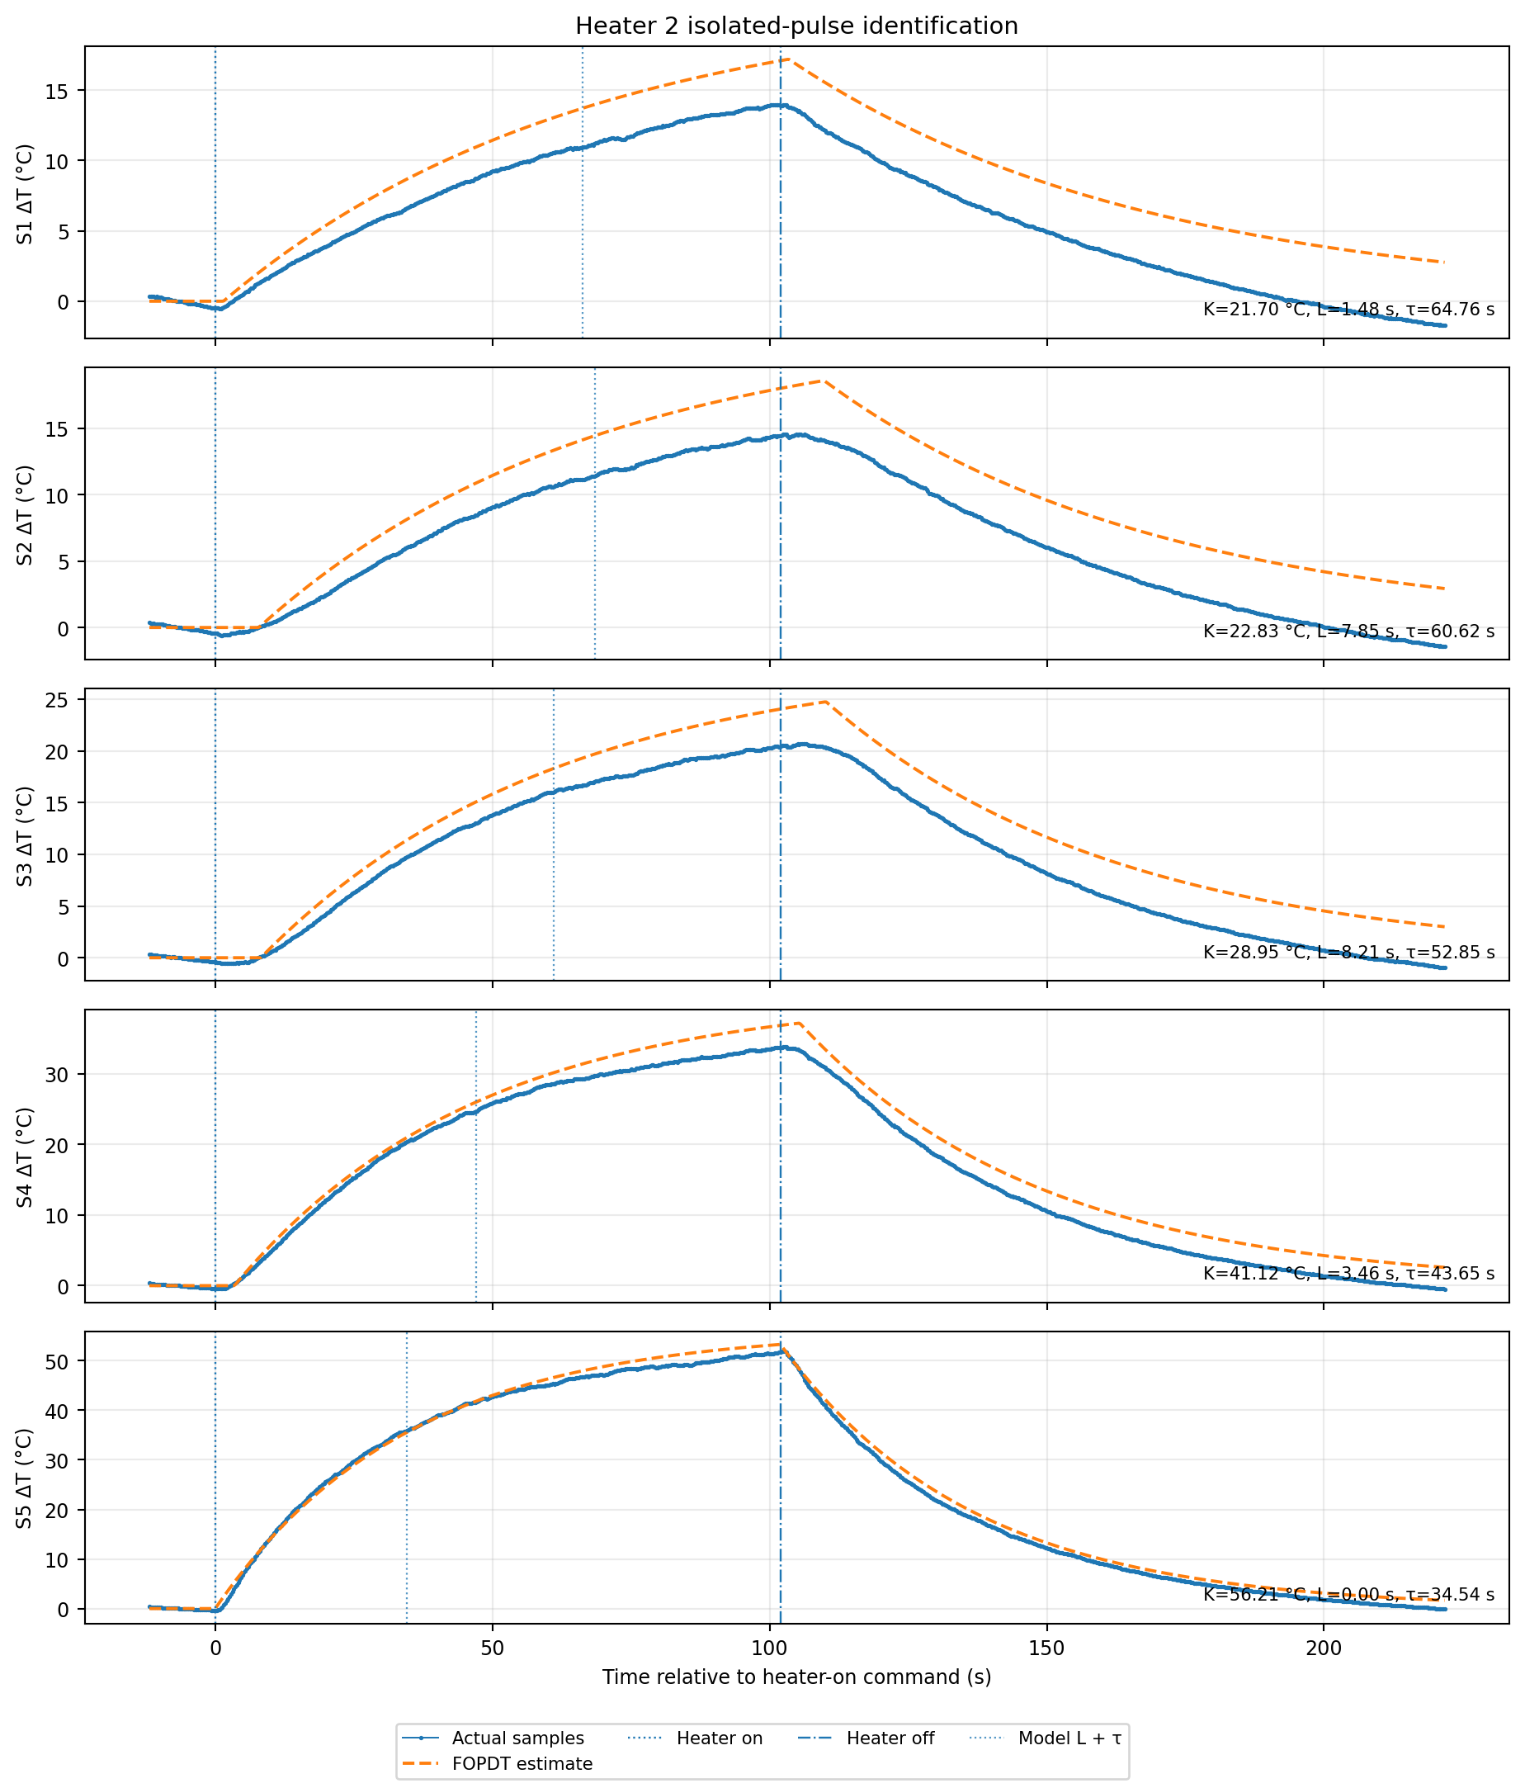
Figure 3. Ambient-corrected samples and FOPDT estimates for the isolated Heater 2 pulse.

5. Identified transfer-function matrix
The transfer-function matrix is
$$G(s) = [G_{11} G_{12}; … ; G_{51} G_{52}]$$
The five output equations are:
$$Θ_{1}(s) = \frac{54.82e^{-1.02s}}{35.69s + 1}U_{1}(s) + \frac{21.70e^{-1.48s}}{64.76s + 1}U_{2}(s)$$
$$Θ_{2}(s) = \frac{40.49e^{-4.04s}}{43.49s + 1}U_{1}(s) + \frac{22.83e^{-7.85s}}{60.62s + 1}U_{2}(s)$$
$$Θ_{3}(s) = \frac{27.12e^{-9.23s}}{52.84s + 1}U_{1}(s) + \frac{28.95e^{-8.21s}}{52.85s + 1}U_{2}(s)$$
$$Θ_{4}(s) = \frac{21.90e^{-8.93s}}{57.59s + 1}U_{1}(s) + \frac{41.12e^{-3.46s}}{43.65s + 1}U_{2}(s)$$
$$Θ_{5}(s) = \frac{20.57e^{-1.59s}}{60.08s + 1}U_{1}(s) + \frac{56.21e^{-0.00s}}{34.54s + 1}U_{2}(s)$$
The static gain matrix is:
$$K = [54.82 21.70; 40.49 22.83; 27.12 28.95; 21.90 41.12; 20.57 56.21] °C$$

6. Symmetry assessment
Path comparison | Mirrored H1 gain | H2 gain | Difference
S1 from H2 vs S5 from H1 | 20.57 °C | 21.70 °C | +5.5%
S2 from H2 vs S4 from H1 | 21.90 °C | 22.83 °C | +4.2%
S3 from H2 vs S3 from H1 | 27.12 °C | 28.95 °C | +6.7%
S4 from H2 vs S2 from H1 | 40.49 °C | 41.12 °C | +1.6%
S5 from H2 vs S1 from H1 | 54.82 °C | 56.21 °C | +2.5%
Table 3. Heater 2 gain compared with the mirrored Heater 1 gain.
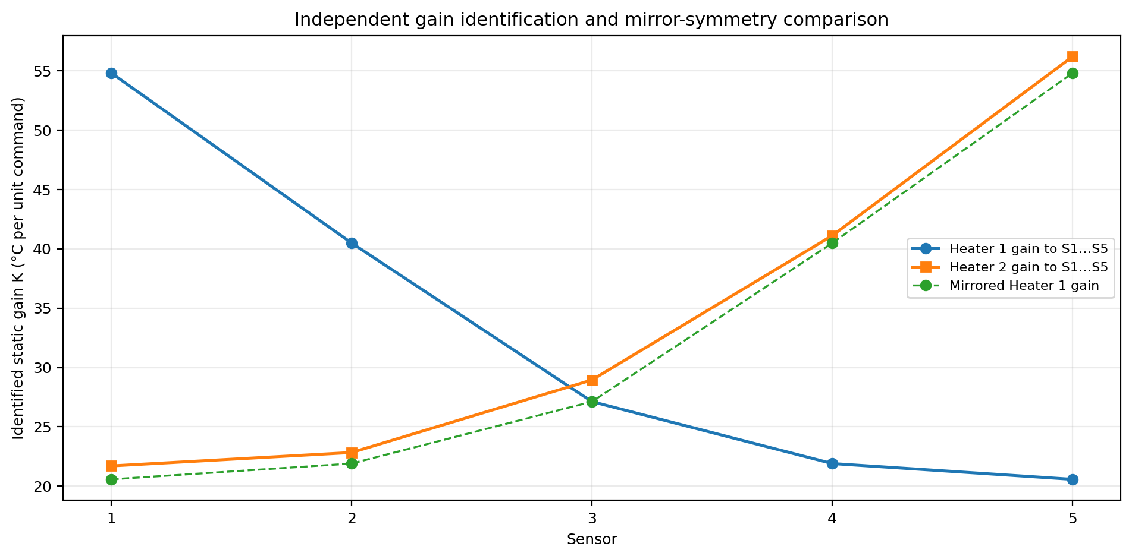
Figure 4. Identified gains demonstrate close, but not perfect, mirror symmetry.

7. Dual-heater superposition test
The strictly linear prediction is the sum of the two independently identified path responses:
$$Θ_{i,linear}(s) = G_{i1}(s)U_{1}(s) + G_{i2}(s)U_{2}(s)$$
This direct sum overpredicts the measured dual-heater response. The following output-specific factors minimize the dual-operation mismatch:
Sensor | Dual-operation factor αᵢ | Interpretation
S1 | 0.769 | 23.1% below direct superposition
S2 | 0.729 | 27.1% below direct superposition
S3 | 0.694 | 30.6% below direct superposition
S4 | 0.692 | 30.8% below direct superposition
S5 | 0.697 | 30.3% below direct superposition
Table 4. Output-specific gain corrections for the dual-heater interval.
A common control-oriented correction is
$$Θ_{i}(s) = 0.717 [G_{i1}(s)U_{1}(s) + G_{i2}(s)U_{2}(s)]$$
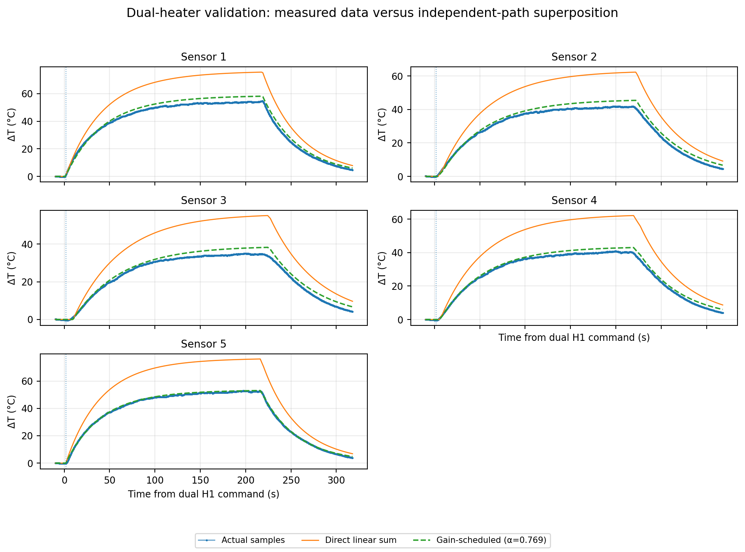
Figure 5. Actual dual-heater samples compared with direct and gain-scheduled superposition.

8. Voltage-sag interpretation
For a resistive heater, electrical power varies with the square of the applied voltage:
$$P = \frac{V^{2}}{R}$$
If the complete common factor α = 0.717 were caused only by voltage sag, then
$$\frac{V_{both}}{V_{single}} = √0.717 = 0.847$$
$$V_{both} = 5.00 × 0.847 ≈ 4.23 V$$
Dual voltage | Voltage sag | Power factor αᵥ | Remaining thermal factor αₜ
5.00 V | 0.00 V | 1.000 | 0.717
4.95 V | 0.05 V | 0.980 | 0.732
4.90 V | 0.10 V | 0.960 | 0.747
4.80 V | 0.20 V | 0.922 | 0.778
4.70 V | 0.30 V | 0.884 | 0.811
4.50 V | 0.50 V | 0.810 | 0.885
4.23 V | 0.77 V | 0.716 | 1.002
Table 5. Electrical power factor and remaining thermal correction for representative voltage sag values.
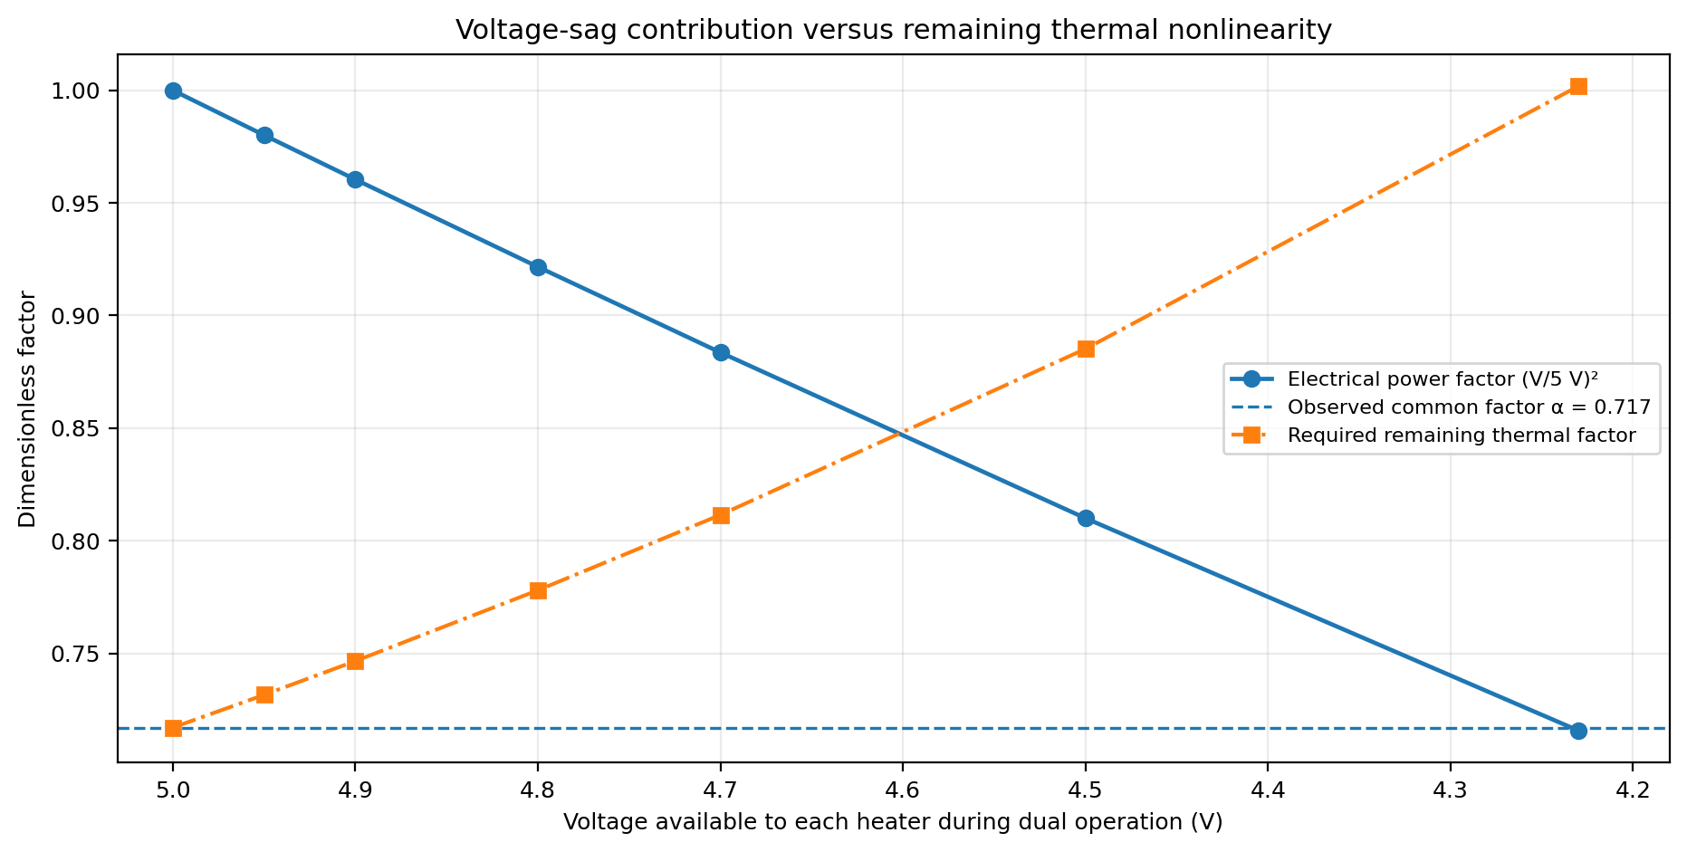
Figure 6. A small voltage sag explains only part of the observed dual-heater reduction.

Interpretation
The data file does not include a voltage channel, so the sag cannot be estimated directly from the temperature record. A 0.20 V reduction from 5.00 V to 4.80 V gives an electrical power factor of 0.922, leaving a thermal factor of approximately 0.778. The remaining reduction is consistent with increasing convection, radiation, and other temperature-dependent losses.

9. Recommended voltage-normalized model
The preferred model preserves the independently identified MISO paths and expresses each input in terms of delivered electrical power:
$$u_{j,eff}(t) = D_{j}(t) [{\frac{V(t)}{V_{reference}}}^{2}]$$
Because Word math nesting is clearer when written explicitly, the intended relationship is duty cycle multiplied by the squared voltage ratio. The corrected temperature model is
$$Θ_{i}(s) = G_{i1}(s)U_{1,eff}(s) + G_{i2}(s)U_{2,eff}(s)$$
When both heaters are active, an additional temperature-dependent factor may be applied:
$$u_{j,corr}(t) = α_{T}(ΔT̄) u_{j,eff}(t)$$

10. Conclusions and next measurements
- Record the actual voltage at each heater during single- and dual-heater operation. A single supply measurement may not reveal unequal wiring or MOSFET drops at the two heater branches.
- Log heater current, or calculate it from a calibrated shunt, so the model input can be expressed directly in watts rather than PWM percent.
- Repeat the three-pulse experiment at two or three duty levels. This will show whether α depends mainly on voltage, mean beam temperature, or total heater power.
- For control design, use the independently identified FOPDT matrix and a common dual-mode factor near 0.72. For simulation, use the output-specific αᵢ values and make the correction temperature dependent.
- Treat the identified gains and time constants as local models around the tested ambient conditions and temperature range.

Appendix A. Parameter summary
Sensor | K₁ | L₁ | τ₁ | K₂ | L₂ | τ₂ | αᵢ
S1 | 54.82 | 1.02 | 35.69 | 21.70 | 1.48 | 64.76 | 0.769
S2 | 40.49 | 4.04 | 43.49 | 22.83 | 7.85 | 60.62 | 0.729
S3 | 27.12 | 9.23 | 52.84 | 28.95 | 8.21 | 52.85 | 0.694
S4 | 21.90 | 8.93 | 57.59 | 41.12 | 3.46 | 43.65 | 0.692
S5 | 20.57 | 1.59 | 60.08 | 56.21 | 0.00 | 34.54 | 0.697
Table A1. Complete FOPDT and dual-operation correction parameters.
Data source and reproducibility files
- Setup1(1).txt — revised raw experiment
- setup1_revised_miso_parameters.csv — identified path parameters
- setup1_revised_miso_model_overlay.csv — actual and modeled full record

